Project 2 Analytics Report
QMB 6358: Data Analytics for Business
Chelsea Anestal
Dr. Ram Govindu
May 7, 2026
Part 1: Predictive Data Mining – Regression Analysis on for Credit Score Data
Introduction
This analysis evaluates multiple predictive data mining techniques using the creditscore.csv dataset to estimate customer credit scored based on financial and behavioral variables. The objective analysis was to compare the predictive performance of five regression methods: Regression Tree, Random Forest Regression, K-Nearest Neighbors (k-NN) Regression, Neural Network Regression, and Regularized Linear Regression.
The dataset was randomly partitioned into 80% training data and 20% testing data using a fixed random seed to ensure reproducibility. Each model was trained using 10-fold cross-validation to reduce overfitting and improve model generalizability. Model performance was evaluated using predictive accuracy metrics generated from the testing dataset.
The analysis also examined the relative strengths and limitations of each modeling approach, including predictive performance, interpretability, and ability to model nonlinear relationships within the credit score data.
Regression Tree Model
Method Overview
Regression tree analysis is a supervised machine learning method that recursively partitions data into smaller groups based on predictor variables. The method creates a tree structure that identifies decision rules associated with changes in the target variable, CreditScore. Regression trees are highly interpretable because they visually display how predictor variables influence predictions.
Analysis Procedure
The regression tree model was develop using the training dataset with 10-fold cross-validation. The complexity parameter (cp) was tuned to determine the optimal level of tree pruning and reduce the risk of overfitting. The model excluded the Individual variable because it served only as an identification index and did not provide predictive value.
Predictions generated from the regression tree model were evaluated using the testing dataset to assess out-of-sample predictive performance.
Summary Results
The regression tree model identified several important predictors associated with customer credit scores, including missed payments, credit usage, and total available credit. The optimal complexity parameter minimized the root mean squared error (RSME) during cross-validation. The regression tree achieved an RSME of 56.93, R-squared of 0.434, and MAE of 44.14, indicating moderate predictive performance while maintaining strong interpretability.
The testing results indicated that the model was capable of identifying nonlinear relationships within the data while maintaining relatively strong interpretability.
Plot: Regression Tree Model
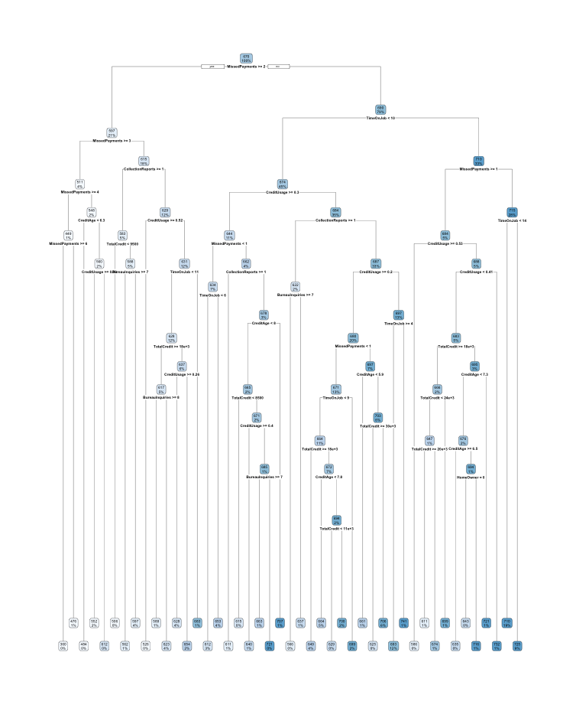
Interpretation
The regression tree results suggest that payment history and credit utilization are major drivers of customer credit scores. Individuals with higher missed payment counts and elevated credit usage generally received lower predicted credit scores.
One advantage of the regression tree model is its interpretability, as the tree structure clearly illustrates the decision-making process used to generate predictions. However, regression trees may be sensitive to small changes in the data and can sometimes overfit when compared to ensemble-based methods such as random forests.
Random Forest Regression
Method Overview
Random Forest Regression is an ensemble learning method that combines predictions from multiple regression trees to improve predictive accuracy and reduce overfitting. Rather than relying on a single decision tree, the method generates many trees using bootstrap sampling and random subsets of predictor variables. Final predictions are produced by averaging the predictions across all trees in the forest.
This approach improves model stability and allows the algorithm to capture complex nonlinear relationships and interactions among variables.
Analysis Procedure
The Randome Forest Regression model was trained using the 80% training dataset with 10-fold cross-validation. The mtry parameter, which determines the number of predictor variables randomly evaluated at each split, was tuned across multiple values to identify the optimal model configuration.
The Individual variable was excluded from the model because it served only as a unique identifier and did not contribute predictive information. Predictions generated from the trained model were evaluated using the 20% testing dataset.
Variable importance metrics were also generated to identify the most influential predictors contributing to credit score estimation.
Summary Results
The Random Forest Regression model produced the strongest predictive performance among all five methods evaluated. The RMSE is 50.67, R-squared is 0.535, and MAE is 39.44. The model achieved the lowest RSME and MAE values while also producing the highest R-squared value, indicating superior predictive accuracy and improved generalization capability relative to the alternative methods.
Plot: Variable Importance Analysis
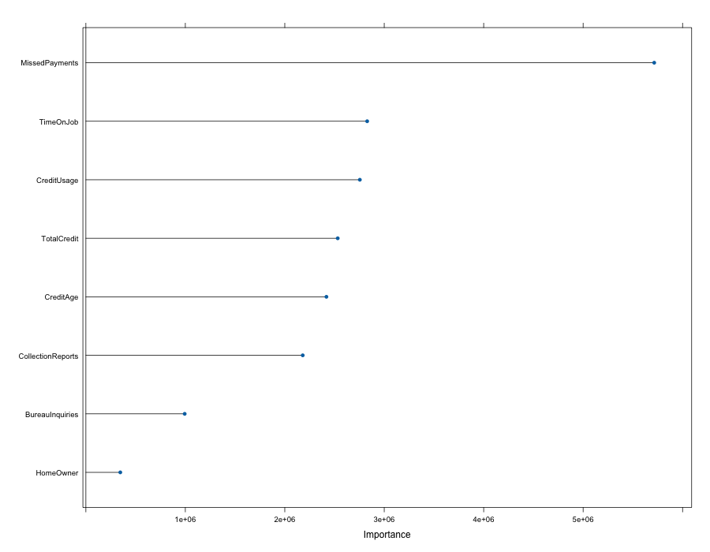
Interpretation
The Random Forest Regression model demonstrated strong predictive performance because ensemble learning reduced variance and improved model stability compared to a single regression tree.
The variable importance analysis indicated that variables related to customer payment behavior and credit utilization had the greatest influence on predicted credit scores. In particular, missed payment history emerged as one of the strongest predictors within the model.
The Random Forest approach was effective at capturing nonlinear relationships and variable interactions that simpler linear models may not fully detect. Although the method is less interpretable than a single decision tree, the improved predictive accuracy suggests that ensemble methods may be more appropriate for credit score estimation problems where prediction quality is prioritized.
k-NN Regression
Method Overview
k-Nearest Neighbors (k-NN) Regression is a nonparametric machine learning method that generates predictions based on the values of observations located closest to a target observation in multidimensional feature space. Predictions are calculated by averaging the the outcomes of the nearest neighboring observations.
Because distance calculations are central to the algorithm, predictor variables were centered and scaled prior to model training to ensure variables with larger numerical ranges did not disproportionately influence predictions.
Analysis Procedure
The k-NN Regression model was trained using the 80% training dataset with 10-fold cross-validation. The tuning process evaluated values of k ranging from 1 to 100 to identify the optimal number of neighboring observations used for prediction generation.
Dummy variables were created for categorical predictors to ensure all input variables were numerically encoded prior to model fitting.
Summary Results
The k-NN Regression model demonstrated relatively strong predictive performance and produced the second-lowest RSME among the evaluated models. RSME is 55.08, R-squared is 0.456, and MAE is 43.06.
The optimal model performance occurred near k=12, indicating that averaging predictions across a moderate number of neighboring observations improved predictive stability.
Plot: k-NN Regression Model
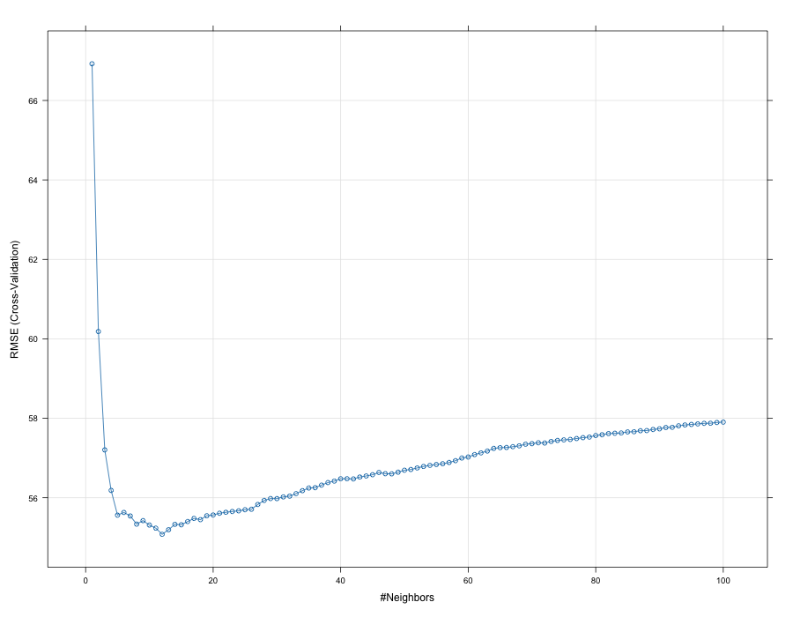
Interpretation
The k-NN Regression model effectively identified local patterns within the credit score dataset and demonstrated strong predictive capability relative to several alternative methods.
The results suggest that observations with similar financial characteristics tend to produce similar credit outcomes. However, because the model relies heavily on local neighborhood structure, predictive performance may be sensitive to noisy observations and the selection of tuning parameters.
Although the k-NN approach produced strong results, the method is less interpretable than tree-based and linear regression approaches because it does not generate explicit decision rules or coefficient estimates.
Neural Network Regression
Method Overview
Neural Network Regression is a machine learning technique designed to model complex nonlinear relationships between predictor variables and target outcome. The model uses interconnected layers of artificial neurons that learn weighted relationships through iterative training processes.
The neural network evaluated in this analysis included a single hidden layer with tuning parameters controlling the number of neurons (size) and regularization strength (decay).
Analysis Procedure
The Neural Network Regression model was trained using the 80% training dataset with 10-fold cross-validation. Predictor variables were centered and scaled prior to training because neural networks are highly sensitive to variable magnitudes.
The tuning process evaluated multiple combinations of hidden layer sizes and decay values to identify the configuration that minimized predictive error.
Summary Results
The Neural Network Regression model successfully captured nonlinear relationships within dataset but produced weaker predictive performance relative to the Random Forest and k-NN models. RSME is 58.71, R-squared is 0.378, and MAE is 45.61.
Although the neural network was capable of learning complex relationships, testing performance indicated that the model may have experienced reduced generalization relative to simpler ensemble-based methods.
Plot: Neural Network Regression Model
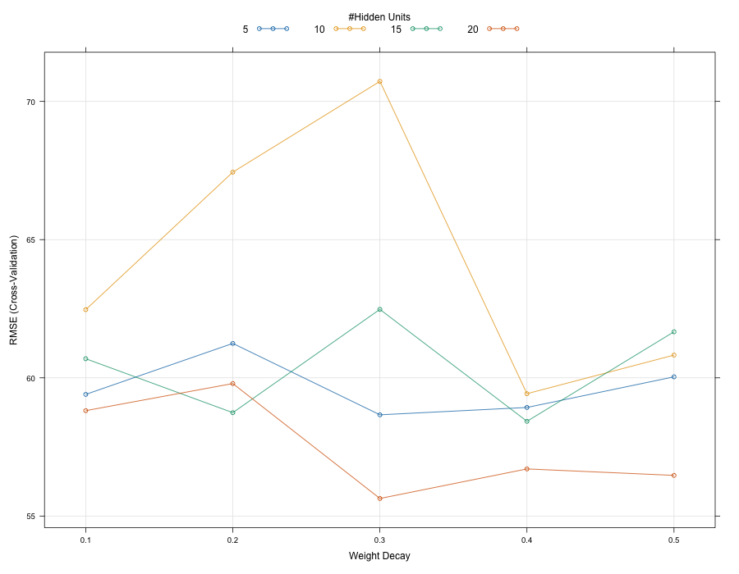
Interpretation
The Neural Network Regression model demonstrated the ability to model nonlinear interactions among financial behavior variables. However, the model produced lower predictive accuracy than Random Forest Regression and k-NN Regression on the testing dataset.
One limitation of neural networks is reduced interpretability because the learned relationships are embedded within hidden layer weights rather than explicitly decision rules or coefficients. Despite this limitation, neural networks remain useful for capturing highly complex relationships in larger and more unstructured datasets.
Regularized Linear Regression
Method Overview
Regularized Linear Regression extends traditional linear regression by introducing penalty terms that reduce model complexity and minimize overfitting. The model in this analysis used regularization methods that combined Ridge and LASSO regression concepts through tuning of the alpha and lambda parameters.
Regularization improves model stability by shrinking coefficient estimates and reducing the impact of highly correlated predictor variables.
Analysis Procedure
The Regularized Linear Regression model was trained using the 80% training dataset with 10-fold cross-validation. Predictor variables were centered and scaled prior to model fitting.
The tuning process evaluated multiple combinations of alpha and lambda values to determine the optimal balance between coefficient shrinkage and predictive accuracy.
Summary Results
The Regularized Linear Regression model produced stable but comparatively weaker predictive performance relative to the Random Forest and k-NN models. The RSME is 58.83, R-squared is 0.373, and MAE is 47.31.
The results indicate that while regularization improved coefficient stability and reduced overfitting, the model was less effective at capturing nonlinear relationships present within the credit score dataset.
Plot: Regularized Linear Regression Model
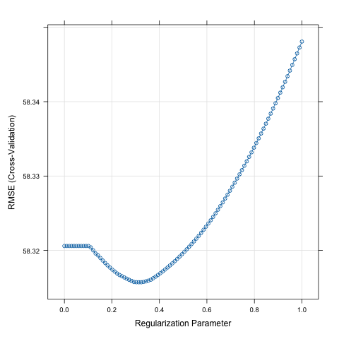
Interpretation
The Regularized Linear Regression model provided the most interpretable frameworks among the evaluated methods because the model retained explicit coefficient estimates and linear relationships between variables.
However, the model produced lower predictive accuracy than the ensemble and neighborhood-based approaches. This suggests the credit score dataset contains nonlinear interactions that are not fully captured through linear modeling techniques alone.
Despite its lower predictive performance, regularized regression remains valuable because its improves model stability, reduces multicollinearity concerns, and maintains interpretability for financial decision-making applications.
Conclusion
The five predictive modeling techniques demonstrated varying levels of predictive performance, interpretability, and model complexity. While all methods were able to identify relationships between financial behavior variables and customer credit scores, the models differed in their ability to generalize patterns within the testing dataset.
Comparative Analysis of Regression Methods
Model | RSME | R-squared | MAE | Strength
Regression Tree | 56.93 | 0.434 | 44.14 | Interpretability
Random Forest | 50.67 | 0.535 | 39.44 | Best predictive accuracy
k-NN | 55.08 | 0.456 | 43.06 | Local pattern recognition
Neural Network | 58.71 | 0.378 | 45.61 | Nonlinear flexibility
Regularized Regression | 58.83 | 0.373 | 47.31 | Simplicity and stability

Among the models evaluated, Random Forest Regression produced the strongest predictive performance based on RSME and overall stability. The ensemble structure of the random forest model reduced variance and improved prediction consistency relative to single regression tree model.
Although the Neural Network Regression demonstrated the ability to model complex nonlinear relationships, the method was less interpretable than tree-based and regularized regression approaches. In contrast, Regularized Linear Regression provided a simpler and more interpretable framework while still maintaining competitive predictive performance.
Overall, the analysis suggests that ensemble learning approaches may provide the most effective balance between predictive accuracy and generalizability.

Part 2: Predictive Data Mining – Classification Analysis on Cellphone Churn Data
Introduction
The purpose of this analysis was to evaluate multiple classification techniques for predicting customer churn within a telecommunications dataset. Customer churn prediction is important because it allows organizations to identify customers at risk of leaving and proactively implement retention strategies. The analysis compared several predictive classification methods to determine which model produced the strongest classification performance.
Data Overview
The dataset analyzed was cellphonechurn.csv, which contained customer account information, usage behavior, and service characteristics. The target variable is Churn (Yes/No). The predictor variables include examples such as AccountWeeks, ContractRenewal, DataPlan, DataUsage, CustServCalls, DayMins, DayCalls, MonthlyCharge, OverageFee, and RoamMins. The Customer variable was treated as an identifier and excluded from modeling.
Data Preparation
The dataset was randomly partitioned into 80% training data and 20% testing data. The training process incorporated 10-fold cross validation, parameter tuning, variable scaling where appropriate, and dummy encoding for categorical variables where necessary.
The models evaluated logistic regression classification, k-Nearest Neighbors classification, classification tree, random forest classification, and neural network classification.
Logistic Regression Classification
Method Overview
Logistic Regression is a statistical classification method used to estimate the probability of a binary outcome. The model predicts churn probability using a logistic transformation that constrains predicted values between 0 and 1.
The method produces interpretable coefficient relationships which makes it widely used in business analytics and even customer retention modeling.
Analysis Procedure
The Logistic Regression model was trained using the 80% training dataset with 10-fold validation. Predictor variables related to customer account behavior, service usage, and customer service activity were used to estimate church probability.
Model performance was evaluated using ROC curves, AUC metrics, and lift curves.
Summary Results
The Logistic Regression model achieved an AUC of 0.825. The ROC curve demonstrated strong classification capability relative to random guessing, while the lift curve indicated meaningful improvement in identifying likely churn customers compared to baseline selection methods.
Plots: ROC-AUC & Lift Curves
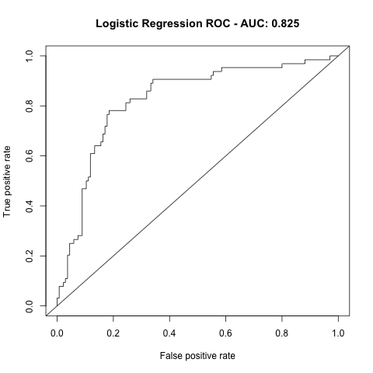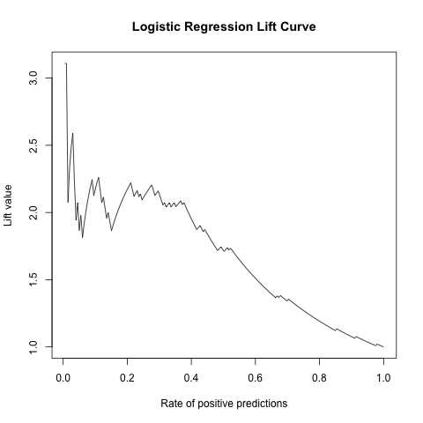
Interpretation
The Logistic Regression model demonstrated strong predictive performance while maintaining high interpretability. The model effectively separated churn and non-churn customers and provided insight into the relationships between customer behavior variables and churn probability.
Although more advanced machine learning models produced slightly strong predictive performance, logistic regression remained valuable because of its simplicity and business interpretability.
k-Nearest Neighbors Classification
Method Overview
k-Nearest Neighbors Classification is a nonparametric machine learning method that classifies observations based on the majority class among neighboring observations within feature space. The method relies heavily on distance calculations; therefore, predictor variables were standardized prior to training.
Analysis Procedure
The k-NN Classification model was trained using the 80% training dataset with 10-fold cross-validation. Multiple values of k were evaluated to determine the optimal neighborhood size.
Two tuning analyses were generated: subset variable tuning and all variable tuning. ROC and lift curves were used to evaluate classification performance.
Summary Results
The k-NN Classification model achieved: AUC =0.879. The tuning plots demonstrated improved classification performance as neighborhood size increased before stabilizing near the optimal value.
Plots: ROC-AUC & Lift Curves; Subset and All Variable Tuning
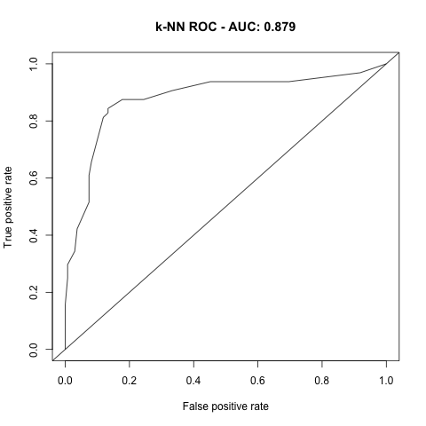
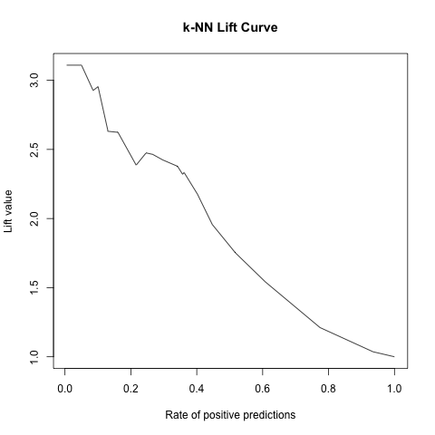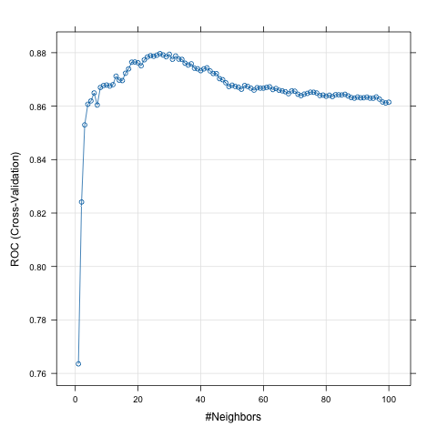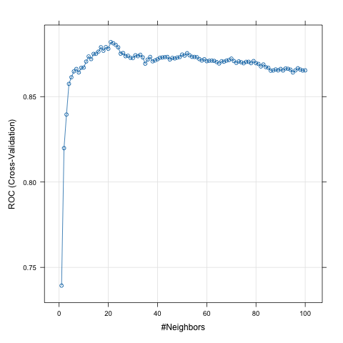
Interpretation
The k-NN Classification model demonstrated strong predictive performance and effectively identified local customer behavior patterns associated with churn risk.
The model achieved substantially higher classification accuracy than logistic regression, suggesting nonlinear customer relationships existed within the dataset.
However, the method is less interpretable because predictions are generated through neighborhood similarity rather than explicit model coefficients.
Classification Tree
Method Overview
Classification Trees partition data into decision-based segments using recursive splitting rules. The method creates highly interpretable classification rules that are easy to visualize and explain.
Analysis Procedure
The Classification Tree model was trained using 10-fold cross-validation with tuning of the complexity parameter to minimize overfitting.
Model evaluation included: ROC curves, lift curves, and tree visualization.
Summary Results
The Classification Tree model achieved: AUC=0.8792. The resulting decision tree identified customer service calls, daily minutes, contract renewal status, and rooming usage as major decision variables influencing churn classification.
Plots: Tree Visualizations, ROC Curves, and Lift Curves
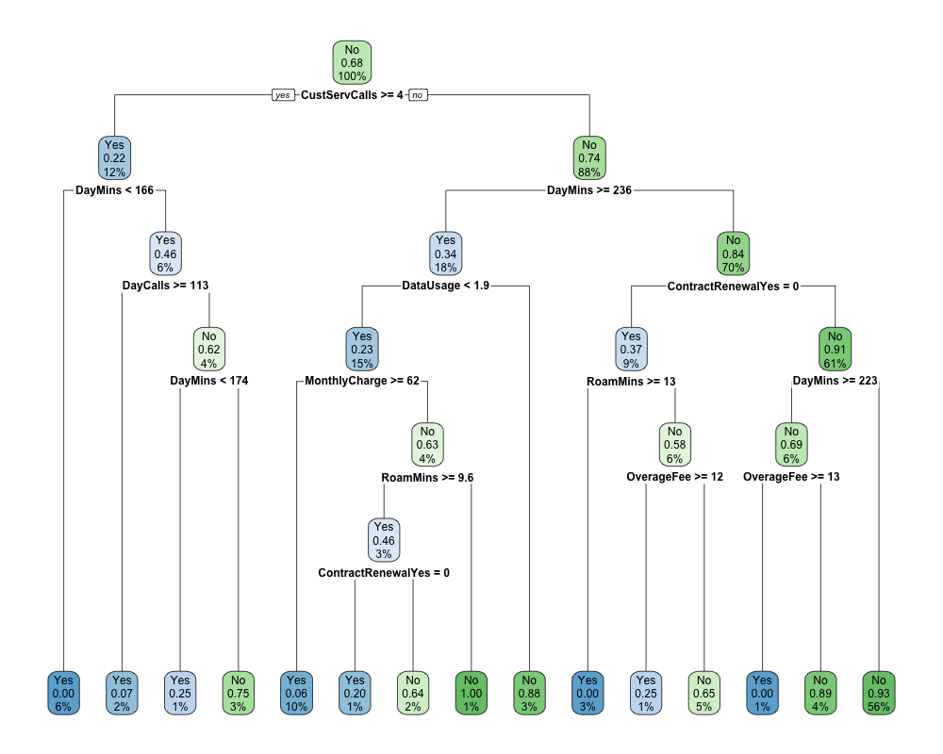
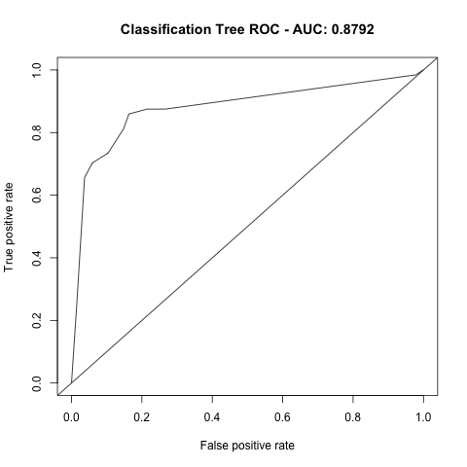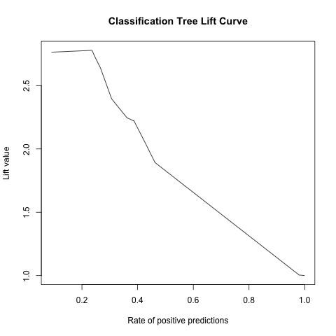
Interpretation
The Classification Tree model produced strong classification performance while also providing highly interpretable decision rules. The tree structure indicated that customers with: high customer service calls, elevated daily minutes, and no contract renewal were substantially more likely to churn.
The interpretability of the model makes classification trees particularly useful in business environments were decision transparency is important.
Random Forest Classification
Method Overview
Random Forest Classification is an ensemble learning technique that combines predictions from multiple classification trees to improve predictive accuracy and reduce overfitting.
The model generates many bootstrap-sampled trees and aggregates their predictions using majority voting.
Analysis Procedure
The Random Forest Classification model was trained using the 80% training dataset with 10-fold cross-validation. Multiple values of mtry were evaluated to optimize classification performance. ROC curves, lift curves, and tuning plot were used to evaluate model performance.
Summary Results
The Random Forest Classification model achieved: AUC=0.9029. This represented the highest AUC among all evaluated classification methods.
Plots: ROC-AUC & Lift Curves; Tuning
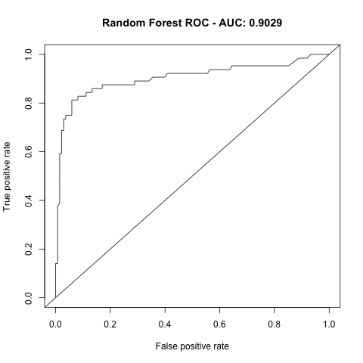
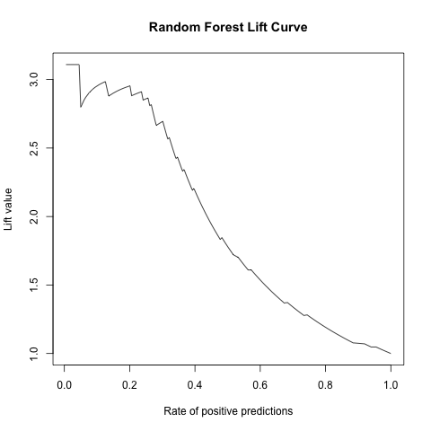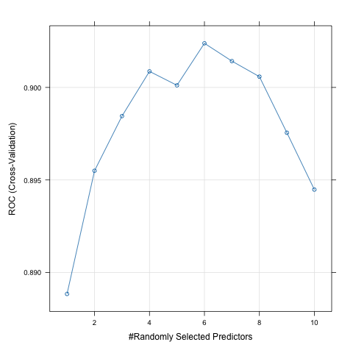
Interpretation
The Random Forest Classification model produced the strongest overall classification performance among all evaluated methods.
The ensemble structure improved predictive stability and allowed the model to effectively capture nonlinear interactions among customer behavior variables.
The high AUC value indicated excellent separation between churn and non-churn customers. The model also maintained strong lift performance, demonstrating practice value for identifying high-risk customers in targeted retention campaigns.
Neural Network Classification
Method Overview
Neural Network Classification models use interconnected hidden layers to learn complex nonlinear relationships within data. The model evaluated in this analysis used varying hidden unit sizes and weight decay parameters.
Analysis Procedure
The Neural Network Classification model was trained using the 80% training dataset with 10-fold cross-validation. Multiple combinations of: hidden units, and weight decay parameters were evaluated to identify the optimal architecture.
Summary Results
The Neural Network Classification model achieved: AUC=0.8939. The tuning plot demonstrated that performance improved as hidden units and decay values increased before stabilizing.
Plots: ROC-AUC & Lift Curves; Tuning
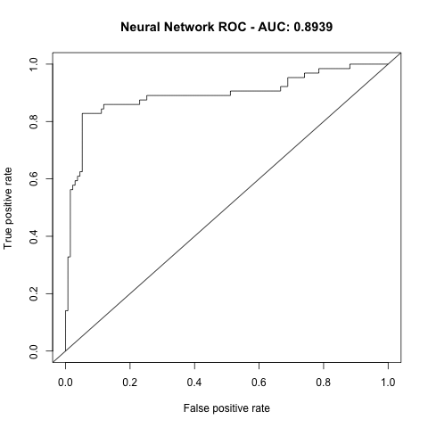
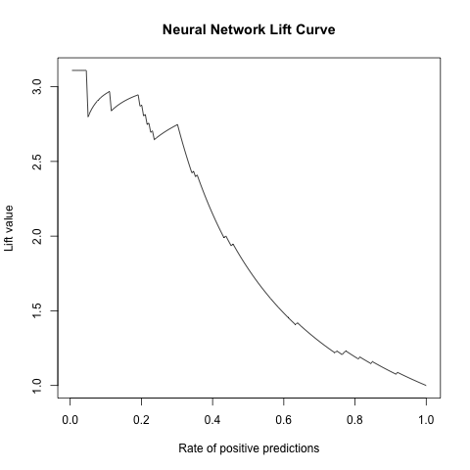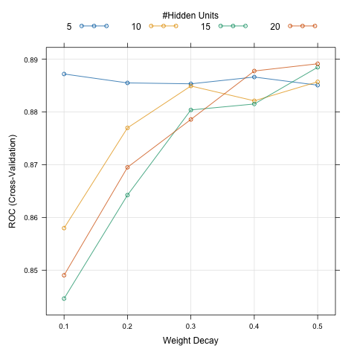
Interpretation
The Neural Network Classification model demonstrated strong predictive capability and effectively captured nonlinear churn patterns within the dataset.
Although the model slightly underperformed the Random Forest classifier, it still achieved excellent classification accuracy.
One limitation of neural networks is reduced interpretability because learned relationships are embedded within network weights rather than explicit rules
Conclusion
The analysis demonstrated that machine learning classification can effectively predict customer churn behavior using telecommunications account and usage data.
Comparative Analysis of All Models
Model | AUC | Strength
Logistic Regression | 0.825 | Interpretability
k-NN Classification | 0.879 | Local pattern recognition
Classification Tree | 0.8792 | Decision transparency
Random Forest Classification | 0.9029 | Best predictive accuracy
Neural Network Classification | 0.8939 | Nonlinear pattern capture
The results demonstrated that ensemble and nonlinear machine learning methods generally outperformed traditional statistical classification methods.
Random Forest Classification achieved the strongest predictive performance due to ensemble averaging, variance reduction, and improved nonlinear relationship modeling,
Neural Networks and k-NN Classification also demonstrated strong classification capability, while Logistic Regression maintained value because of its interpretability and simplicity.
Random Forest Classification produced the strongest overall results because it achieved: the highest AUC, strong ROC performance, and strong lift curve behavior. The model demonstrated superior ability to distinguish churn and non-churn customer relative to the alternative methods.
The findings suggest that customer service activity, usage behavior, and contract renewal characteristics play significant roles in predicting churn risk and can support proactive customer retention strategies.

Part 3: Predictive Analytics – Optimization Case Study
Problem Overview
Walsh’s Juice Company’s objective is to minimize total monthly costs. These include transportation costs from vineyards to plants and product processing costs at each plant.


Decision Variables
The shipment and production amounts are the major decision variables. Shipment variables (X1-X12) represent tons of unprocessed grape juice shipped from each vineyard to each plant. Production variables (X13-X24) represent tons of each product processed at each plant.
Objective Function
The objective function is to minimize total cost: Transportation cost + processing cost. The minimize Z is equal to the sum product of each of these against their cost matrices outlined.
Constraints
The constraints include vineyard supply, plant capacity, product demand, and material balance constraints. Along with these constraints is the nonnegativity restriction on the decision variables.
Excel Solver Setup
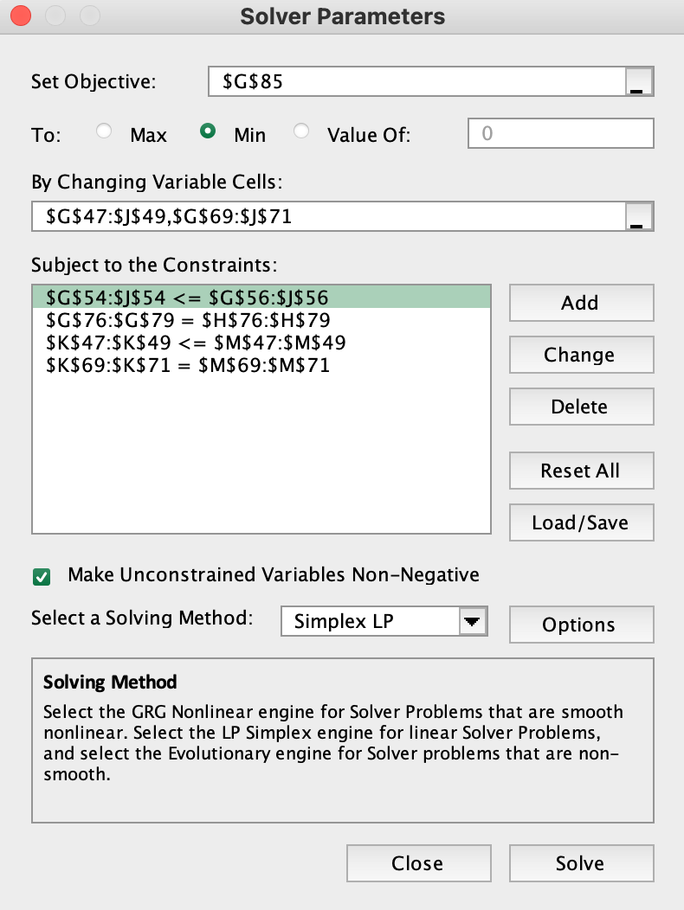
Optimal Solution Results
The minimized solution cost was $10,606,000.00. This was the sum of the transportation cost which was $3,146,000.00 and the processing cost which was $7,460,000.00.
Interpretation
Solver found an optimal solution with a minimum total cost of $10,606,000. This includes $3,146,000 in transportation costs and $7,460,000 in processing costs. The solution satisfies all product demand requirements and plant material balance constraints. Michigan, Tennessee, and Indiana operate at full capacity, while Virginia has unused capacity of 1,050 tons. From the vineyard supply perspective, New York and Pennsylvania are fully utilized, while Ohio has 150 tons of unused available supply. Overall, the optimal solution minimizes by routing production primarily through the most cost-effective plant and shipment combinations while still satisfying demand and capacity limits.

